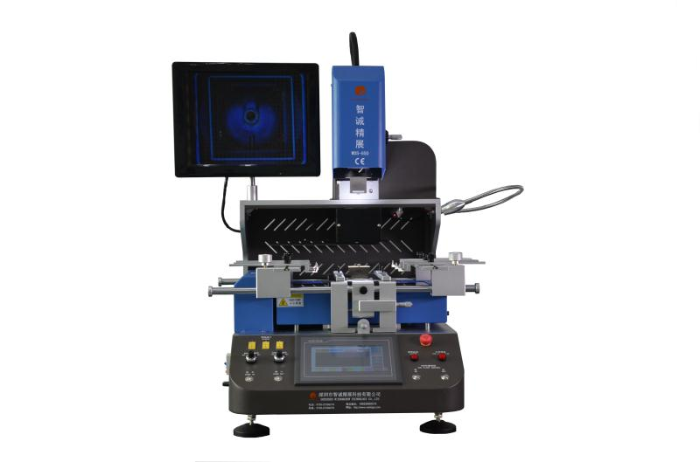

Independent 3 heating zones temperature control system
1.The upper and lower hot air heating, IR preheating zone adopts imported infrared gold-plated light tube to heat up quickly,which can heat up at the same time from the top of he component to the bottom of the PCB, to make the PCB board heated averagely,ensure welding effect;bottom IR heating,temperature precision control within ±1℃.8 segment temperature control independently.Infrared gold-plated light tube control heating independently.
2.Hot air district heating for BGA and PCB at the same time,and large area IR heater preheating up for the bottom of PCB to avoid completely PCB deformation during reworking,the upper or lower temperature zones could be used alone and combine freely the energy of up and lower heating element.
3.Adopted high precision K-type thermocouple close-loop control and PID parameter self-setting system;
4 temperature curves can be displayed with instant curve analysis function and multi-group user data can be saved;temperature can be tested precisely through external measurement interface,curves can be analysed,set and correct on the touch screen at any time.
Precision optical alignment system
Using high definition and adjustable CCD color optical alignment system,beam split、amplification、lessening、fine adjustment and auto focus with the function that automatic color aberration resolution and brightness adjustment,adjustable image contrast;equipped with 15 ” high definition LCD monitor.
Multi-functional and humanized operation system
- Adopting the HD touch human-machine interface;upper heating head and mounting head designed 2 in 1;providing many kinds of titanium alloy BGA tuyere can be rotated in 360 degree for easy installation and replacement.
- X、Y and R angle adopted micrometer fine-tuning,accuracy locating,precision can reach ±0.01mm.
Superior safety protection function
With the alarm function, after the BGA welding the machine can alarm by itself.In the case of temperature abuse, the circuit can power off automatically with the double over-temperature protection.Temperature parameter having password protection to prevent any modification.

Technology parameter
1 | Power supply | AC 110V/220V±10％ 50/60Hz
2 | Total power | Max 6400W
3 | Heater power | Upper temp.zone 1200W,second temp.zone 1200W,IR temp.zone 4000W
4 | Locating way | V shape slot,PCB support jigs can adjust，laser light do fast centering and position
5 | Temperature controlling | （high precision K-sensor）（Closed Loop),independent temp.controller,the precision can reach ±1℃
6 | Electrical material | Driving motor+ smart temp.controller+color touch screen
7 | PCB size | Max 410×380mm Min 10×10 mm
8 | Applicable chips | Max 80×80mm Min 1×1 mm
9 | Applicable pcb thickness | 0.3-5mm
10 | Alignment system | Optical lens + HD industrial camera
11 | Mounting accuracy | ±0.01mm
12 | Temperature Interface | 3 pcs
13 | Tin spot monitoring | Optional external camera to monitor solder ball melting process during welding
14 | Camera in and out | Auto out & in
15 | Overall dimension | L600×W640×H850mm
16 | Weight of machine | 60KG
17 | Other function | 5 working modes. Semi auto/ manual /mount/weld/remove mode switch freely

